The St. John's University Departments of English, Fine Arts, and Core Studies
invite you to a Round-Table and Discussion
exploring
Oceanic New York
Featuring artistic, literary, and eco-theoretical responses to salt water, coastlines, Hurricane Sandy, the “Loomings” chapter of Moby-Dick, and other encounters with the sea and the City

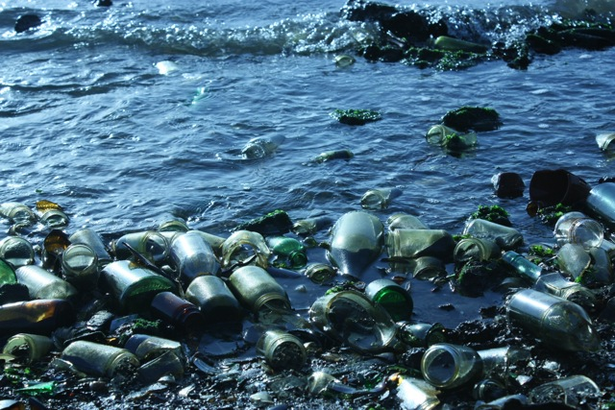
(Photo of Dead Horse Bay by Jamie Skye Bianco)

Participants Jamie Skye Bianco, NYU
Jeffrey Jerome Cohen, George Washington University
G. Ganter, St. John's University
Eileen Joy, Punctum Books
Allan Mitchell, University of Victoria
Nancy Nowacek, Artist
Karl Steel, Brooklyn College, CUNY
Marina Zurkow, Artist

Moderator Steve Mentz, St. John's University

Th September 26, 6-8 pm, Geoffrey Yeh Art Gallery, St. John's University
Light refreshments will be served

